HOW TO ACTIVATE YOUR PORTAL ACCOUNT: STEP-BY-STEP GUIDE

Welcome to SmartVault! As a guest user, you'll enjoy secure access to shared folders, files, and documents. However, before you can start using SmartVault, you need to activate your account. This article will guide you through the process of starting your guest account and signing into SmartVault.
Wait for your Activation Invitation
Your accountant or document preparer initiates the process by inviting you to create a SmartVault guest account. To locate and identify the activation email, here are some key details to look out for:
  - Sender: The activation email will come from your SmartVault account manager, who invited you to create your guest account.
  - Subject Line: Look for an email with the subject line "[Name of the SmartVault account manager] has shared the vault '[Your Name]' with you".
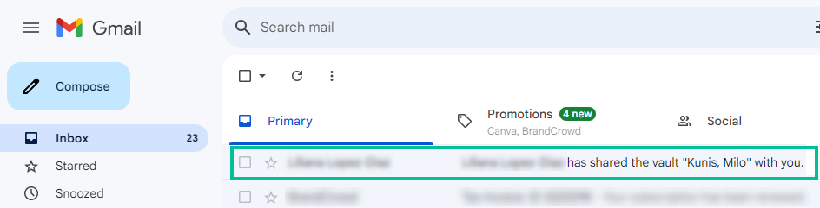
Note
If the activation email is not in your primary inbox, please check your spam or junk mail folders. If you have yet to receive your activation email, ask the SmartVault account manager to resend the invitation.
Activating your Guest Account
Once you have received the activation email from SmartVault:
- Open your activation email from SmartVault.
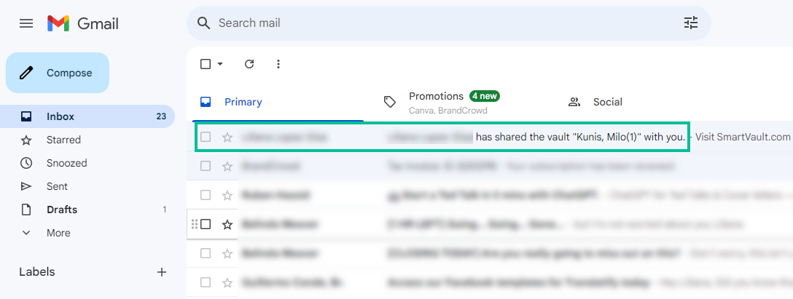
- Click the Activate button, which is accompanied by the SmartVault logo.
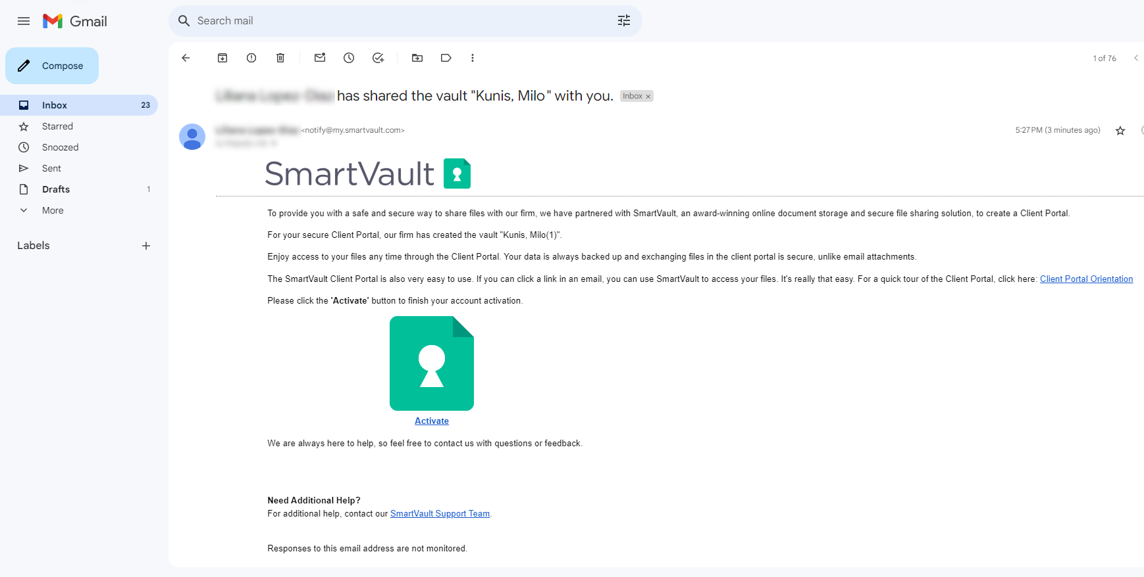
- On the activation page, enter your phone number and choose a secure password.
Note
Your other personal details are pre-filled automatically.
- Click Create My User to complete your account setup.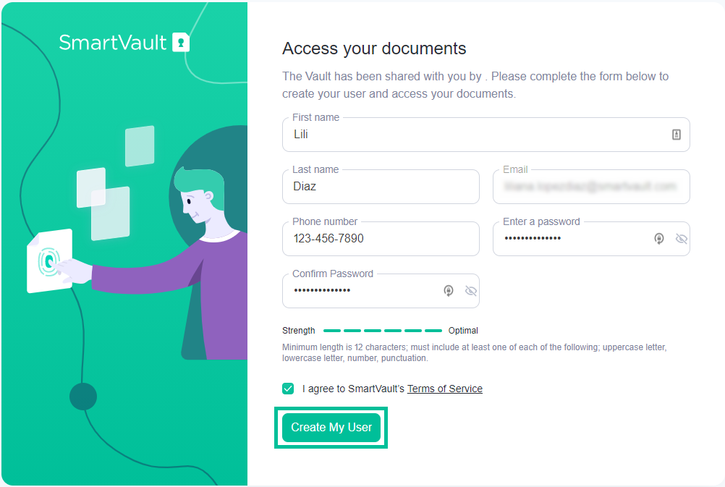
Signing In to your SmartVault Guest Account
Now that you've activated your account, you can start using SmartVault.
- Go to the SmartVault portal, or mobile app.
- Enter the email address and password you used when activating your guest account.
- Click Sign In.
Note
If you have forgotten your password, click Can't sign in? and follow the instructions to reset your password.
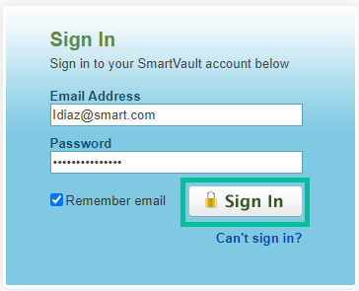
By following these steps, you can set up your SmartVault guest account and start using it.

